**Some interesting findings from EDA:**

* We found that in one of the constituency in **Gujarat, Surat** no election has been held and **BJP**, the leading party won with put contesting.

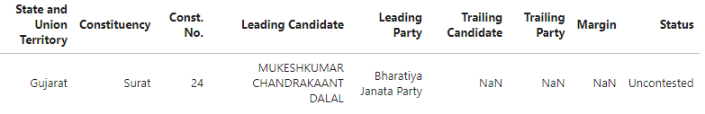

* We can see that the leading party has almost 52% vote share and no other party comes close to its majority. Congress stands at second position with 21% vote share which is significantly less compared to the leading party.

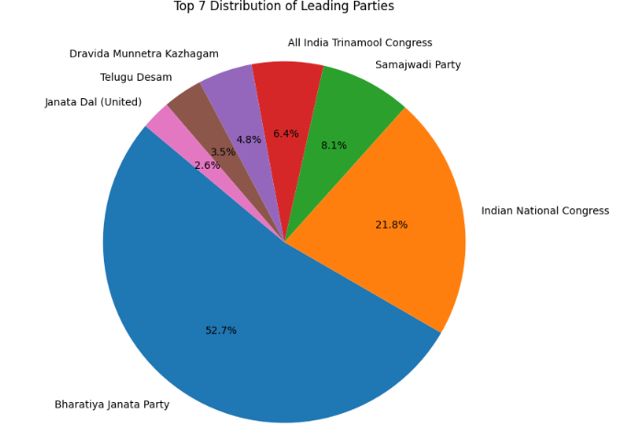

* Here is a list of candidates and constituencies with top 10 highest winning margins. This plot here shows that these are the areas where the candidates have a strong hold on the vote share. These leaders shattered previous records, demonstrating their strong mandate and popularity among voters 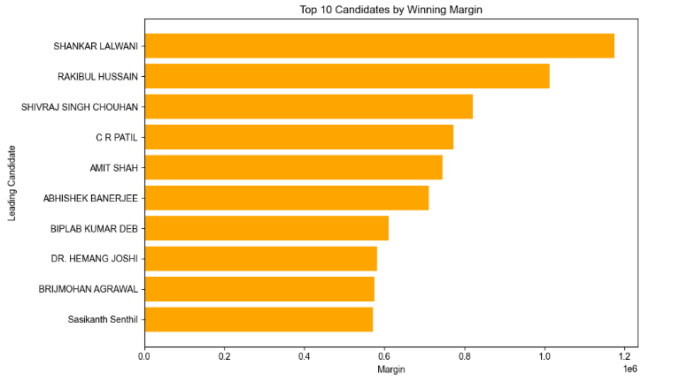

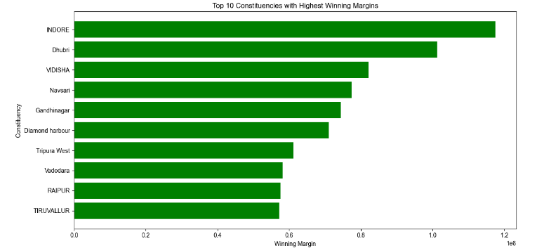

* This plot here shows the list of constituencies with lowest winning margins. This demonstrates that no particular leader or party has a strong vote share in these areas and the competition among the candidates is high.

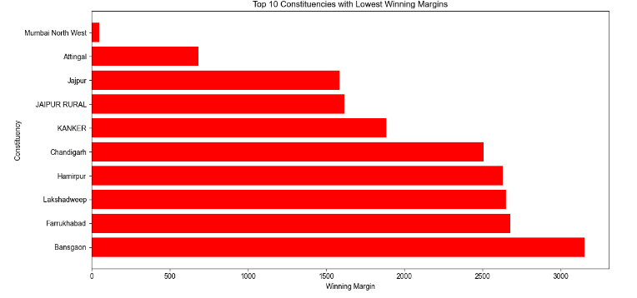

* This plot here highlights the performance of the major leaders in the country. Although narendra modi won in his constituency, he is not the one with highest margins among the popular leaders.
* Amith shah is the one with highest margin with around 7.44 lakh margin votes. Rahul Gandhi won with a margin of 3.9 lakhs and Akhilesh won with 1.7 lakhs.

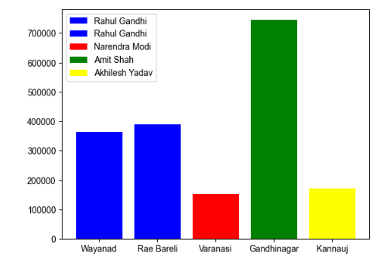

* This plot shows the distribution of seats per states with Uttar Pradesh having the highest number of seats, followed by Maharastra and West Bengal. The party with majority seats won in these states will have an edge in the election and BJP is the party in rule in these states which is also the leading party.

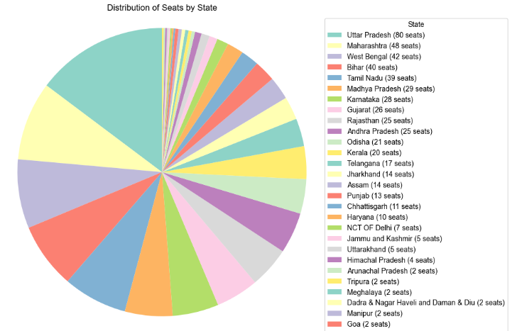

* This plot shows the performance of the leading party BJP in all states. The major contributors to its vote share are Uttar Pradesh, Madhya Pradesh and Gujarat.

